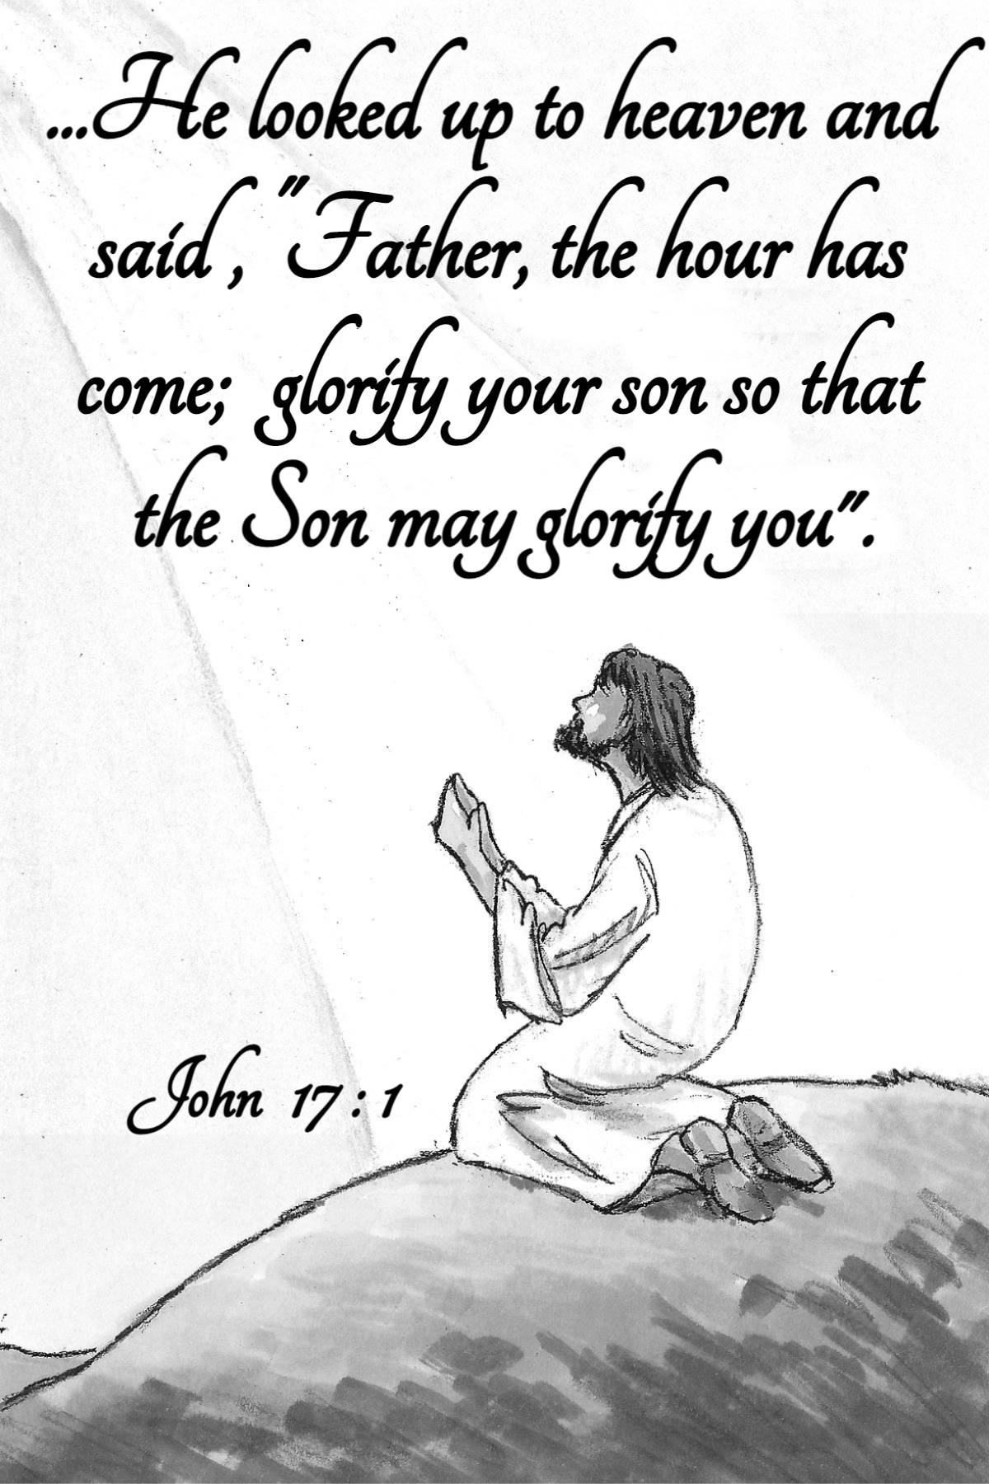

May 21, 2023

Charity Lutheran Church
17220 Kelly Rd., Detroit, Michigan 48224

Phone (313) 527-4337
www.charitylutherandetroit.org

Rev. Dietrick Gladden

(248) 719-2766
dietrick.gladden@michigandistrict.org

Emeritus Pastor: Rev. John Duerr

Welcome - To all who need comfort; to all who want friendship; to those who desire acceptance; to all who want sheltering love; to those who sin and need a Savior, whoever will come, this church opens wide its doors, and in the name of our Lord, says WELCOME!

Visitors - We welcome you to Charity! We hope that hearing God's Word this morning will strengthen and enrich your faith. Please introduce yourself to Pastor Gladden.

THE ORDER OF WORSHIP
Invocation

P: In the name of the Father and of the † Son and of the Holy Spirit.
C: Amen.

Opening Song

“The Heart of Worship”

Apostles’ Creed

Prayer of the Day

Sharing of the Peace

L: The peace of the Lord be with you always.
C: And also with you.
(share the peace with one another)

First Reading Acts 1:12–26
¹²Then [the apostles] returned to Jerusalem from the mount called Olivet, which is near Jerusalem, a Sabbath day’s journey away. ¹³And when they had entered, they went up to the upper room, where they were staying, Peter and John and James and Andrew, Philip and Thomas, Bartholomew and Matthew, James the son of Alphaeus and Simon the Zealot and Judas the son of James. ¹⁴All these with one accord were devoting themselves to prayer, together with the women and Mary the mother of Jesus, and his brothers. …

L: This is the Word of the Lord.
C: Thanks be to God.

New Testament 1 Peter 4:12–19; 5:6–11
¹²Beloved, do not be surprised at the fiery trial when it comes upon you to test you, as though something strange were happening to you. ¹³But rejoice insofar as you share Christ’s sufferings, that you may also rejoice and be glad when his glory is revealed. ¹⁴If you are insulted for the name of Christ, you are blessed, because the Spirit of glory and of God rests upon you. ¹⁵But let none of you suffer as a murderer or a thief or an evildoer or as a meddler. ¹⁶Yet if anyone suffers as a Christian, let him not be ashamed, but let him glorify God in that name. ¹⁷For it is time for judgment to begin at the household of God; and if it begins with us, what will be the outcome for those who do not obey the gospel of God? ¹⁸And “If the righteous is scarcely saved, what will become of the ungodly and the sinner?” ¹⁹Therefore let those who suffer according to God’s will entrust their souls to a faithful Creator while doing good. …
⁶Humble yourselves, therefore, under the mighty hand of God so that at the proper time he may exalt you, ⁷casting all your anxieties on him, because he cares for you. ⁸Be sober-minded; be watchful. Your adversary the devil prowls around like a roaring lion, seeking someone to devour. ⁹Resist him, firm in your faith, knowing that the same kinds of suffering are being experienced by your brotherhood throughout the world. ¹⁰And after you have suffered a little while, the God of all grace, who has called you to his eternal glory in Christ, will himself restore, confirm, strengthen, and establish you. ¹¹To him be the dominion forever and ever. Amen.

L: This is the Word of the Lord.
C: Thanks be to God.

Holy Gospel John 17:1–11
¹When Jesus had spoken these words, he lifted up his eyes to heaven, and said, “Father, the hour has come; glorify your Son that the Son may glorify you, ²since you have given him authority over all flesh, to give eternal life to all whom you have given him. ³And this is eternal life, that they know you the only true God, and Jesus Christ whom you have sent. ⁴I glorified you on earth, having accomplished the work that you gave me to do. ⁵And now, Father, glorify me in your own presence with the glory that I had with you before the world existed.
⁶“I have manifested your name to the people whom you gave me out of the world. Yours they were, and you gave them to me, and they have kept your word. ⁷Now they know that everything that you have given me is from you. ⁸For I have given them the words that you gave me, and they have received them and have come to know in truth that I came from you; and they have believed that you sent me. ⁹I am praying for them. I am not praying for the world but for those whom you have given me, for they are yours. ¹⁰All mine are yours, and yours are mine, and I am glorified in them. ¹¹And I am no longer in the world, but they are in the world, and I am coming to you. Holy Father, keep them in your name, which you have given me, that they may be one, even as we are one.”

L: This is the Gospel of the Lord.
C: Praise to You, O Christ!

Song of the Day

“I Can Only Imagine”

Sermon

Confession and Absolution

L: If we say we have no sin, we deceive ourselves, and the truth is not in us.
C: But if we confess our sins, God, who is faithful and just, will forgive our sins and cleanse us from all unrighteousness.

(silence for reflection and self-examination)

L: Let us then confess our sins to God our Father.
C: Most merciful God, we confess that we are by nature sinful and unclean. We have sinned against You in thought, word, and deed, by what we have done and by what we have left undone. We have not loved You with our whole heart; we have not loved our neighbors as ourselves. We justly deserve Your present and eternal punishment. For the sake of Your Son, Jesus Christ, have mercy on us. Forgive us, renew us, and lead us, so that we may delight in Your will and walk in Your ways to the glory of Your holy name. Amen.
L: Almighty God in His mercy has given His Son to die for you and for His sake forgives you all your sins. As a called ordained servant of Christ, and by His authority, I therefore forgive you all your sins in the name of the Father and of the † Son and of the Holy Spirit.
C: Amen.

Offering

(If you wish to make a contribution, please place it in the offering plate as you exit the sanctuary)

Prayer of the Church

Service of the Sacrament

Preface

L: The Lord be with you.
C: And also with you.
L: Lift up your hearts.
C: We lift them to the Lord.

L: Let us give thanks to the Lord our God.
C: It is right to give Him thanks and praise.

Lord’s Prayer

L: Lord, remember us in Your kingdom and teach us to pray:

Distribution

Distribution Song

“None Like You”

Announcements

Closing Song

“Show Me Your Glory”

Benediction

